HOP Count | IP Address | Organization (IP Owner) | Location (US state)/Country
1 | 192.168.1.1 | Internet Assigned Numbers Authority (IANA) | Los Angeles,CA,USA
2 | 23.51.180.232 | Akamai Technologies, Inc. | Cambridge,MA,USA
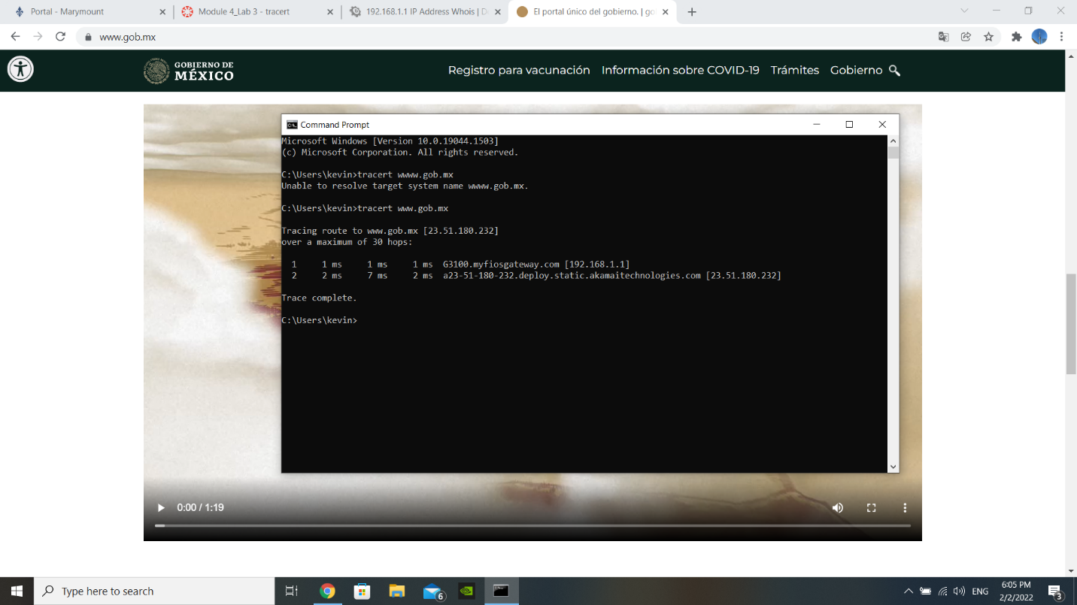

https://www.gob.mx/

